DAY-8

*1) Create view vw_updatable_products (use same query whatever I used in the training) Try updating view with below query and see if the product table also gets updated. Update query: UPDATE updatable_products SET unit_price = unit_price * 1.1 WHERE units_in_stock < 10;*/

**Query:**

CREATE OR REPLACE VIEW vw_updatable_products AS

SELECT product_id,product_name,supplier_id,category_id,quantity_per_unit, unit_price,units_in_stock,units_on_order,reorder_level,discontinued

FROM products WHERE discontinued = 0;

**OUTPUT:**

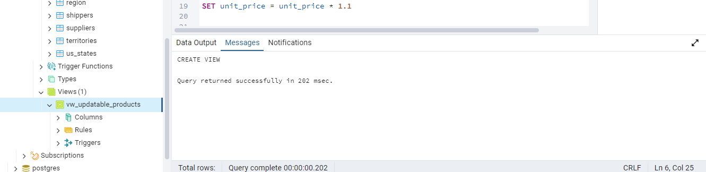

SELECT product_id, product_name, unit_price, units_in_stock FROM vw_updatable_products WHERE units_in_stock < 10;

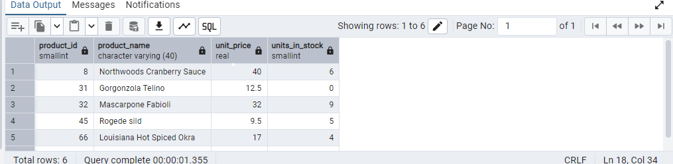

UPDATE vw_updatable_products SET unit_price = unit_price * 1.1

WHERE units_in_stock < 10;

**OUTPUT:**

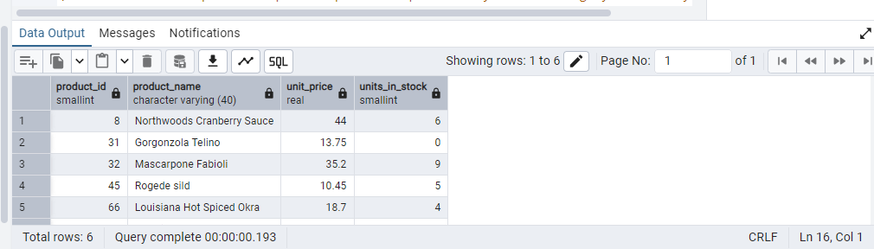

2. *2.Transaction:--Update the product price for products by 10% in category id=1.--Try COMMIT and ROLLBACK and observe what happens. -- Start transaction*/ BEGIN;

**TO COMMIT:**

**Query:**

BEGIN;

SELECT product_id, product_name, unit_price AS original_price

FROM products

WHERE category_id = 1;

UPDATE products

SET limit_price = unit_price * 1.10

WHERE category_id = 1;

SELECT product_id, product_name, unit_price AS updated_price

FROM products

WHERE category_id = 1;

COMMIT;

**To check:**

SELECT product_id, product_name, unit_price AS final_price

FROM product WHERE category_id = 1;

**OUTPUT:**

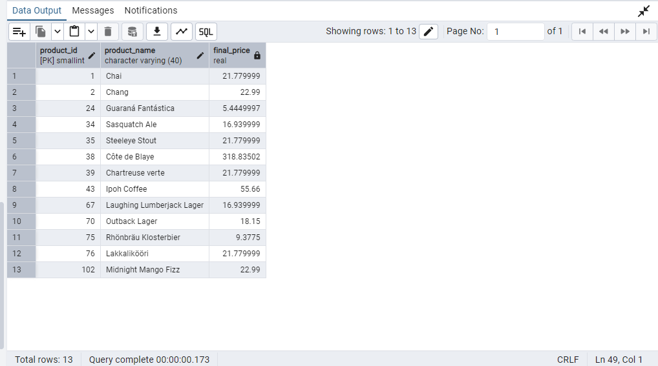

**TO ROLLBACK**

**Query:**

BEGIN;

SELECT product_id, product_name, unit_price AS original_price

FROM products

WHERE category_id = 1;

UPDATE products

SET unit_price = unit_price * 1.10

WHERE category_id = 1;

SELECT product_id, product_name, unit_price AS updated_price

FROM products

WHERE category_id = 1;

ROLLBACK;

To check:

SELECT product_id, product_name, unit_price AS final_price FROM products

WHERE category_id = 1;

**OUTPUT:**

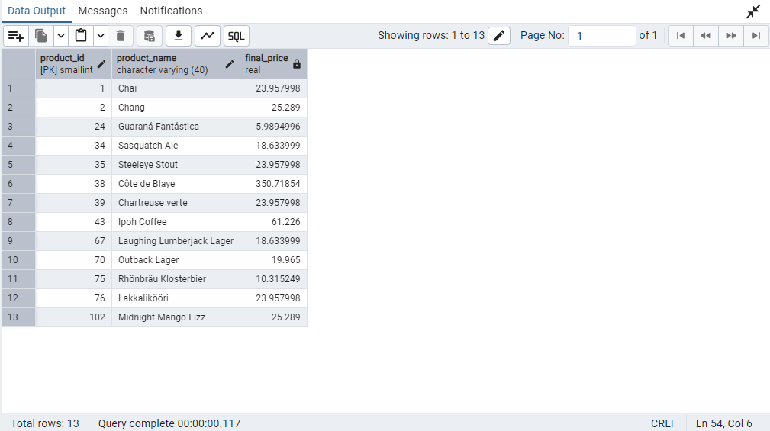

3. Create a regular view which will have below details (Need to do joins):--Employee_id,

--Employee_full_name,

--Title,

--Territory_id,

--territory_description,

--region_description

**Query:**

CREATE OR REPLACE VIEW vw_employee_territories AS

SELECT

e.employee_id,

CONCAT(e.first_name, ' ', e.last_name) AS employee_full_name,

e.title,

t.territory_id,

t.territory_description,

r.region_description

FROM

employees e

JOIN

employee_territories et ON e.employee_id = et.employee_id

JOIN

territories t ON et.territory_id = t.territory_id

JOIN

region r ON t.region_id = r.region_id

ORDER BY

r.region_description,

t.territory_description,

employee_full_name;

**OUTPUT:**

